Targeted Nonprofit Relief Media Toolkit

Table of Contents
Introduction……………………………………………………………………..…...…….3
PANO’s Legislative Proposals: Nonprofit Designated Support………………………4
Link to PANO’s Advocacy Platform (for easy engagement w. staff officials)……….5
Sample Press Release/Op-Ed…...……………………………………………………. .6
Sample Email to Send to Your Elected Officials…………………………..…….…….7
Sample Email for Clients/Constituents to Send to Elected Officials…………………8
Sample Social Media Posts…………………………………………………….………..9
Graphic / Colors & Font………………………………………………………………….10
Additional Resources…………………………………………………………………….11

Introduction
We are one year into the COVID-19 Pandemic. Some nonprofits have received support from:
- The CARES Act
- Local funders
- Some shifts in state regulations
- County-distributed funds
but Pennsylvania’s General Assembly has not targeted support for the nonprofit sector or provided guidance to counties to provide designated nonprofit support. Thus, nonprofits often have to compete with local business for funding and other support.
The Pennsylvania Association of Nonprofit Organizations (PANO) is asking state officials to provide more support for nonprofits from the Commonwealth. It will make our advocacy work most effective is if nonprofits in every community throughout Pennsylvania communicate this same message to their local elected officials. Legislators want to know the impact on their own communities and you are best people to talk about that impact.
The “Targeted Relief for Nonprofits” Media Toolkit provides sample language for your outreach efforts. In addition, PANO is using its own advocacy platform, so you can easily sign and send our message directly to your elected officials with just a few clicks.
This campaign goal is two-fold:
- To use our collective voice to drive funding and support to Pennsylvania nonprofits. If we all speak, we are 807,000 people strong!
- To underscore that collective voice with local stories that will drive our message home.
We plan to do this through this “Targeted Relief for Nonprofits” campaign. This toolkit supplies participating organizations with sample language for telling your own stories to support the broad campaign message which is simple:
Nonprofits need targeted relief-NOW.

All of you have stories that demonstrate local need. This kit gives every organization and community language to edit to best tell that story across multiple platforms. As a grassroots effort, this campaign will only be as effective as your efforts and your ability to leverage your network, and the networks of those in your network.

PANO’s Legislative Proposals
PANO’s legislative requests are on our website, and you are welcome to attach them to emails you may send. We are also including the information here so that you can use it in your own messaging.
Nonprofit organizations are social and economic drivers in Pennsylvania. Nonprofits have a workforce of over 807,000 employees, generate $116.7 billion in annual revenue, and serve millions of Pennsylvania residents.

In response to the pandemic, Pennsylvania’s nonprofits need targeted support from the Commonwealth. Nonprofits partner with government to meet mandated, basic needs for our most vulnerable citizens, and are essential workers.

And yet, the Commonwealth has not designated funding or other relief to these critical partners, unlike other states.

Funding Proposals
PANO asks you, our elected officials, to support/co-sponsor the following funding proposals:

- Nonprofit Economic Emergency Delivery System (NEEDS) Grants Program ($200 M)
  - To be introduced by Senator Judy Ward
  - HB 1116: Introduced by Representative Natalie Mihalek

- Establishing the COVID-19 Nonprofit Assistance Grant Program ($100 M)
  - HB 347 introduced by Representatives Leanne Krueger and Melissa Shusterman

Funding Need
- 87% of nonprofits experienced a negative financial impact resulting from COVID-19.
- In August 2020, 808 nonprofits reported a -$708 Million total impact, and this report reflects only 2% of Pennsylvania nonprofits.
- Of note, 88% of nonprofits have budgets of <$500,000, with the smaller organizations experiencing the most negative impact as seen in Table 1 below.

Table 1: COVID-19 Impact on Nonprofits by Budget Size
Budget Size | Average Loss & Expenses | Impact as % of Total Revenue
Under $100,00 | -$16,000 | -47%
$101,000- $500,000 | -$100,000 | -37%
$501,000-$2.5 M | -$317,000 | -26%
$2.5-$10 M | -$1.3 M | -24%
More than $10 M | -$3.9 M | -7%

Unemployment Proposal
PANO asks you to support the following proposal:
- Amend state law to provide for 100% reimbursement of COVID-19 related unemployment claims of nonprofit reimbursable employers.

Need for Relief for Unemployment Claims
- As of December 2020, 60,000 nonprofit workers in Pennsylvania remained unemployed due to the pandemic.
- In a March 2021 survey, 41 reimbursable Pennsylvania nonprofits reported a 1,876% increase in unemployment between Mar 1, 2020 – Feb 28, 2021 compared to Mar 1, 2019 – Feb 28, 2020. The associated unemployment claims increased by 442% ($10.9 M) during the same period. This is only a snapshot of those impacted.
Link to PANO’s Advocacy Platform
Use this sample email for your clients and constituents to contact legislators. Please fill in the highlighted areas with your organization’s information.
Follow this link (link to Salsa Labs Letter) to sign on to PANO’s letter to elected officials.

Note: We will include a copy of that letter here so people can see it.

Sample Op-Ed/Press Release
Use this sample Op-Ed to share why it is important for nonprofits to survive in your community. Please fill in the highlighted areas with your organization’s information.
FOR IMMEDIATE RELEASE CONTACT:
[DATE] [Name, Title]
[Phone | Email]

[YOUR ORGANIZATION’S NAME] Needs Targeted COVID-19 Relief Now
Nonprofit organizations are social and economic drivers in Pennsylvania. Nonprofits have a workforce of over 807,000 employees, generate $116.7 billion in annual revenue, and serve millions of Pennsylvania residents. [YOUR COUNTY] is home to # nonprofits (Look up the number via Tax Exempt World.) These organizations partner with state and local government to provide mandated services to those most in need. The pandemic led to:
Lost Revenues + Skyrocketing Unemployment = Devastating Nonprofit Impact
- Lost Revenues – Most (87 percent) have taken a financial hit, with smaller non-profits, those with budgets under $500,000, experiencing the most financial upheavals, losing nearly half their revenues.
- Skyrocketing Unemployment – Unemployment for nonprofits rose a staggering 1,800 percent from March 2020 to February 2021, while unemployment claims rose more than 400 percent, or $10.9 million, during the same period.
And yet, the Commonwealth has not designated funding or other relief to critical partners, like [YOUR ORGANIZATION’S NAME].
[YOUR ORGANIZATION’S NAME] serves [XYZ POPULATION] which is necessary service because XYZ…
- Your non-profit story – how did COVID-19 and unemployment claims impact you?
- Did the demand for your services increase or decrease? How did that shift in demand impact your ability provide services?
- Did you have to lay off employees? If so, how many? And ultimately, how many clients no longer received the same level of service compared to pre-pandemic? And how did that impact them (e.gl, increasing mental health challenges, etc.)?
Without the targeted support of our state and local officials, [YOUR ORGANIZATION’S NAME] will not recover for at least another X years.

###
About [Your Nonprofit]
[Add a description of your organization here]

Sample Email to Send to Your Elected Officials
Use this sample email to send to state senators and representatives, urging them to support your nonprofit-now. Please fill in the highlighted areas with your organization’s information.
Find your individual state legislators’ information here.
SUBJECT: [YOUR ORGANIZATION’S NAME] Needs Targeted COVID-19 Relief-NOW
Dear [enter name],
As you work on the 2021-22 state budget, please make sure that nonprofit relief is front and center in your discussions. As you know, nonprofits partner with you and county government to ensure that the needs of Pennsylvanians are met. [YOUR COUNTY] is home to # nonprofits (Look up the number via Tax Exempt World.) The Commonwealth has provided opportunities for nonprofits to compete for pandemic-related funding. But unlike other states, Pennsylvania relief packages have not yet targeted support for this critical sector, resulting in differing levels of support at best.
The following two funding proposals have been introduced in the House. Please help us by cosponsor/support either one or both.
- Nonprofit Economic Emergency Delivery System (NEEDS) Grants Program ($200 M)
  - To be introduced by Senator Judy Ward
  - HB 1116: Introduced by Representative Natalie Mihalek

- Establishing the COVID-19 Nonprofit Assistance Grant Program ($100 M)
  - HB 347 introduced by Representatives Leanne Krueger and Melissa Shusterman

In addition, we need unemployment claims relief for nonprofits. As of December 2020, 60,000 nonprofit workers in Pennsylvania remained unemployed due to the pandemic.
- In a March 2021 survey, reimbursable Pennsylvania nonprofits reported a 1,876% increase in unemployment between Mar 1, 2020 – Feb 28, 2021 compared to Mar 1, 2019 – Feb 28, 2020. The associated unemployment claims increased by 442% ($10.9 M) during the same period. This is only a snapshot of those impacted.

This lack of support has made a difference for [YOUR ORGANIZATION’S NAME].
- Your non-profit story – how did COVID-19 and unemployment claims impact you?
- Did the demand for your services increase or decrease? How did that shift in demand impact your ability provide services?
- Did you have to lay off employees? If so, how many? And ultimately, how many clients no longer received the same level of service compared to pre-pandemic? And how did that impact them (e.gl, increasing mental health challenges, etc.)?
Please don’t hesitate to reach out if you have questions. My direct line is XXX-XXX-XXXX.
Thank you for your support during this difficult time.

Sample Email to Send to Clients/Constituents
Use this sample email for your clients and constituents to contact legislators. Please fill in the highlighted areas with your organization’s information.
Provide the email information for the specific legislator you want your clients/constituents to contact. Please explain that you’d like your clients to fill out the letter and e-mail it from their home e-mail to their state legislators.
TO: State Senator or Representative
SUBJECT: [YOUR ORGANIZATION’S NAME] Needs Targeted COVID-19 Relief-NOW
Dear [enter name],
My name is [first name]. [XYZ Organization] provides me and my family with [services]. My neighbors, friends, family, and community count on [XYZ Organization]’s services.
Support one or both of these funding proposals:
The following two funding proposals have been introduced in the House. We ask you cosponsor/support either one or both.
- Nonprofit Economic Emergency Delivery System (NEEDS) Grants Program ($200 M)
  - To be introduced by Senator Judy Ward
  - HB 1116: Introduced by Representative Natalie Mihalek

- Establishing the COVID-19 Nonprofit Assistance Grant Program ($100 M)
  - HB 347 introduced by Representatives Leanne Krueger and Melissa Shusterman

I depend on [XYZ Organization] for [services]. This is how my life will be impacted if [XYZ Organization] no longer exists in my community.

Sample Social Media Posts
TWITTER
87% of PA nonprofits have been negatively impacted by COVID-19, with some reporting over 1800% increase in unemployment. Without relief, [YOUR ORGANIZATION’S NAME] will be unable to serve our XXX clients. #Relief4PAnonprofits
87% of PA nonprofits have been negatively impacted by COVID-19, with 35% serving fewer or no clients. Without relief, [YOUR ORGANIZATION’S NAME] PA nonprofits will be unable to serve our XXX clients. #Relief4PAnonprofits
Lost Revenues + Skyrocketing Unemployment = Devastating Nonprofit Impact. YOUR ORGANIZATION’S NAME] saw an X% increase in unemployment over the last year. #Relief4PAnonprofits
@legislator support HB116 or SBXXX to provide $200 Million in NEEDS grants to support [YOUR ORGANIZATION’S NAME]! #Relief4PAnonprofits
@legislator support HB347 to provide $100 Million in Nonprofit Assistance grants to support [YOUR ORGANIZATION’S NAME]! #Relief4PAnonprofits
[YOUR ORGANIZATION’S NAME] and other nonprofits are social and economic drivers in PA. Nonprofits have a workforce of over 807,000 employees, generate $116.7 billion in annual revenue, and serve millions of PA residents. #Relief4PAnonprofits
FACEBOOK
Since the beginning of the pandemic, the Commonwealth of Pennsylvania has not designated relief for nonprofit organizations that partner with the state to provide government-mandated and community-based services. Typically, [YOUR ORGANIZATION’S NAME] employs # employees and serves # individuals in [YOUR COUNTY]. During the pandemic, we have seen the demand for our services increase/decrease by X%. What this means for our community is: [1-3 bullet points about COVID-19’s impact on your clients and community].
  - Bullet Point #1
  - Bullet Point #2
  - Bullet Point #3
@legislator, amend state law to provide for 100% reimbursement of COVID-19 related unemployment claims of all nonprofit employers, whether or not we are reimbursable.

Graphic
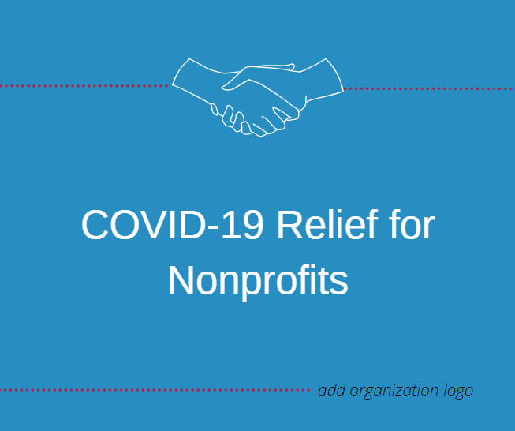

Access and edit the above image here:
Colors & Font
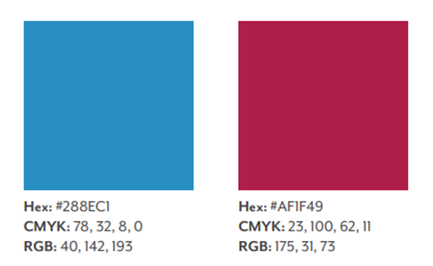
Calibri (size 12)

Additional Resources
Where to Find Your Elected Officials:
- Members of Pennsylvania’s General Assembly
- County Commissioners, Mayor, City Council Members

Where to Find the Number of Nonprofits in Your County:
- Tax Exempt World
- COVID-19 Impact on Nonprofits
- COVID-19 Impact on Nonprofits by County
- Needs of Pennsylvania Residence by Referral Request

