Review Process for Accreditation, Standards Basics and Standards Basics Enhanced

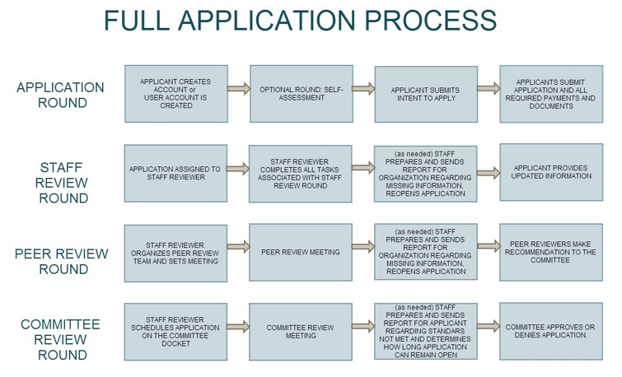

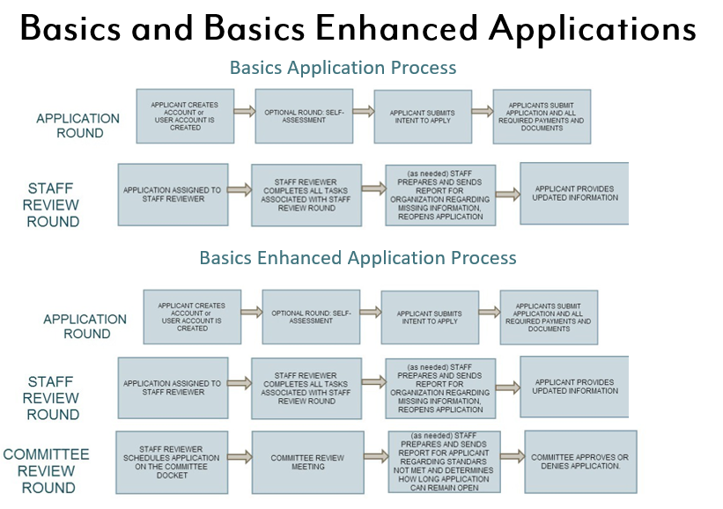

List of Peer Reviewers

Kevin I. Bagatta
Real Alternatives
Harrisburg, PA

- Stephanie Bucklew
SLB Consulting
Pittsburgh, PA

Rex Cassel
Cassel Consulting, Inc.
West Chester, PA

Jacqueline Catrabone
Strategy Solutions, Inc.
Erie, PA

Stephanie Cory
Independent Philanthropy
& Governance Consultant
West Chester, PA

Joseph Cuozzo
Bucks County Opportunity Council
Doylestown, PA
- Kathleen Czupich, MBA
Doylestown, PA 18902

Lisa DeGori
CORA Services, Inc.
Philadelphia, PA

Jessica Dreisdadt
The Fruition Coalition
Easton, PA
Paula Eppley-Newman
Beginnings, Inc.
Johnstown, PA

Sue Erdman
Joseph T. Simpson Public Library
Mechanicsburg, PA

Barbara Ernico
Charitable Advisory Services
Hilton Head, SC

Ann Feightner
Total Senior Care
Allegany, NY 14706

- Theresa Fox
Fox, Morter & Associates Consulting
Butler, PA

Janet E. Garretson
Girl Scouts of the USA
New York, NY

- Marvin Gold
Marvin E. Gold, Fund Raising Counsel
Pittsburgh, PA

- Monica Gould
Strategic Consulting Partners
Mechanicsburg, PA

Aaron S. Grumbling, CPA
Dauphin County Library System
Harrisburg, PA

Cynthia H. Griffith
CHG Financial and Accounting Services
Wallingford, PA

- Karen Hosler Kispert, Ph.D.
Delaware County Women Against Rape
Media, PA

Marilyn A. Jenkins
Allegheny County Library Association
Pittsburgh, PA

- Elaine Keckeissen
Doylestown Presbyterian Church
Doylestown, PA (Southeast Region)

Betsy Keefer
Community Volunteer
York, PA

Patricia Kosinski
Former Executive Director Family Support Line of Delaware County, Inc., Media, PA

- Angela Liddle
PA Family Support Alliance
Harrisburg, PA

Rosemary Martinelli
Martinelli & Associates Consultants
Adjunct Faculty-Penn State University,
Point Park University
Pittsburgh, PA

Robert J. Mather
RJM Consultants
Kent, Ohio

Nancy Montvydas, CFRE
Soroptimist International of the Americas
Philadelphia, PA (Southeast Region)

- Mary Leslie Mulligan
Community Integrated Services
Philadelphia, PA (Southeast Region)

- Karen Mundie
Greater Pittsburgh Literacy Council
Pittsburgh, PA (Southwest Region)

- Amy Myers
Union Fire Company No. 1
Carlisle, PA

- Jordan Pallitto
The Hill Group, Inc.
Carnegie, PA

Jill Reeder
Pearl S. Buck International
Perkasie, PA

- Nancy E. Sabol
St. Benedict Education Center
Erie, PA

Stephen Scanlon
Marietta, PA

Nicolle Schnovel
Berks Connections/Pretrial Services
Reading, PA

Lisa K. Schweyer
Pittsburgh, PA

- Leah Spangler
The Learning Lamp
Johnstown, PA

Rosalind Spigel
Spigel Consulting
Bryn Mawr, PA

- Catherine Stetler
City of Harrisburg
Harrisburg, PA

- Debra Thompson
Strategy Solutions, Inc.
Erie, PA

Raymond Thompson
Operation Outward Reach
Belle Vernon, PA

Marsha A. Tongel, Ph. DS.
Tongel Consulting Group, Inc.
DBA Metanoia-TCG, Inc.
Pittsburgh, PA

Jill Troutman
Children’s Home of York
York, PA, 17406

Elizabeth Vibber
Bee, Bergvall & Co./Bucks County Center for Nonprofit Management
Warrenton, P

Robert C. Whitmore
Strategic Consulting Partners
Chambersburg, PA (Central Region)

