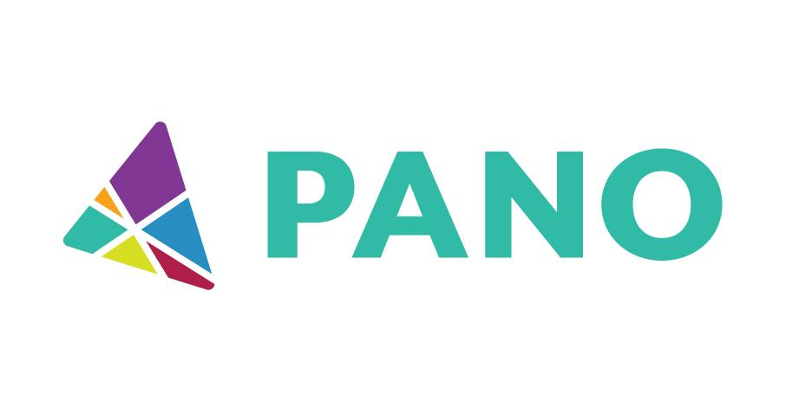
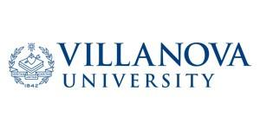

REQUEST FOR SPEAKER, FACILITATOR, AND SYNTHESIZER PROPOSALS
Thank you for your interest in submitting a session proposal for the 2026 Collaborative Conference, presented in partnership by the PA Association of Nonprofit Organizations (PANO) and Villanova University's Department of Public Administration.

SUBMISSION DEADLINE is 5:00 PM ET on Thursday, June 4, 2026. You will be notified of our committee’s selection decisions by 5:00 PM ET on Thursday, June 18, 2026.
2026 Collaborative Conference | Rooting Deeper, Rising Together

ABOUT THE 2026 COLLABORATIVE CONFERENCE

THE BASICS
When: Thursday, September 24, and Friday, September 25, 2026
Where: The Penn Stater Hotel & Conference Center, 215 Innovation Blvd State College, PA 16803
Tentative Daily Schedule: September 24, 10:00 AM-6:00 PM | September 25, 8:00 AM-2:30 PM
Session Lengths: 75-Minutes Learning Sessions | 90-Minute Working Sessions

THE CONTEXT
The work of our 2025 Collaborative Conference, Meeting the Moment – Rooted Together, was finding each other beneath the surface. With our 2026 theme of Rooting Deeper, Rising Together, we’ll begin the work of doing more together, turning connection into action. We will go deeper into that work and rise into our strength together, claiming a more visible role in our communities, in policy, and in shaping what comes next. We rise together because our roots run deep and stay connected. The conference is where we’ll practice what rising together actually looks like.

CONFERENCE GOALS & CONDITIONS FOR SUCCESS

2026 Collaborative Conference Aspirations
- Energize a statewide movement built on nonprofit solidarity and strategic advocacy.
- Offer opportunities for leaders to experience inspiration, feel less isolated, and engage in meaningful collaboration.
- Create space for joy, fun, and real talk – because movement-building requires relationship-building, rest, and connection.

Conditions for Success
Engage nonprofit professionals from:
- Multiple cross-sectors (e.g., the arts; parks and recreation; mental health/behavioral health; autism/intellectual disabilities; health/women’s health; childcare; LGBTQ+ serving organizations; food insecurity; disaster response organizations.
- Various geographical regions – rural and urban communities from all six (6) regions across the state.
HOW YOU CAN HELP FACILITATE MEANINGFUL LEARNING AND DEEP CONNECTIONS WITHIN PA’S NONPROFIT NETWORK

Nonprofits continue to operate in an increasingly complex and challenging environment. As such, we're seeking proposals that will support conference attendees in rooting deeper into the relationships, purpose, and strength that have carried us through to now, and rising together into the work we are called to do. Formats include working sessions and learning sessions. Each session will be supported by a synthesizer.

- Working Sessions should be designed not just to inform, but to gather attendees around a common challenge and offer time, tools, and frameworks to move toward solutions together in real time. This could look like real-world simulations, design-thinking activities, “impact labs”, and more.
- Learning Sessions should be designed to provide some context around the topic chosen – with questions and prompts to generate stories and ideas from those on the ground doing the work. This could look like a more “traditional” workshop format, where facilitators share timely, relevant information, invite attendees to discuss how this topic is showing up in their work, and offer practical, actionable takeaways.
- Synthesizers will help us capture what’s shared, synthesize insights, and connect dots for attendees (this is a role we explored in 2025 and are excited to fully implement this year!).

This is a conference that thrives on collaborative sessions rather than top-down delivery.
Facilitators with both subject matter expertise and true facilitation skills are encouraged to apply, as well as nonprofit professionals with valuable, on-the-ground experience. We're especially excited to receive proposals from leaders whose lived experiences reflect the full diversity of Pennsylvania's communities, including BIPOC presenters, rural changemakers, multilingual and multicultural practitioners, and anyone bringing perspectives that are often overlooked but deeply needed. We welcome teams who blend content expertise with community-rooted insight.

Proposals should reflect the conference's primary goals:
- Rooting Deeper (Strengthening Our Individual Organizations and Our Collective Network): Sessions should aim to bring conference attendees together in meaningful ways that will support collaboration during and after the conference. Bonus points for building in time and space for people to have fun together, get real together, and inspire one another!
- Rising Together (Statewide Movement Building): Sessions should reflect and support the unique challenges and strengths of Pennsylvania's nonprofit ecosystem, and offer frameworks, tools, or ideas that can be shared, adapted, and scaled across roles, regions, and areas of work.

We encourage submissions that incorporate the following:
- Inclusive practices that recognize and celebrate the diverse lived experiences of our audience;
- Engaging formats that go beyond lectures (participatory activities, storytelling, case studies, design-thinking, play, etc.);
- Opportunities for attendees to connect and interact – within and across subsectors, roles, and regions; and
- Reflection questions that draw on participants' wisdom.
PREPARING YOUR PROPOSAL
The following sections detail what the conference team is looking for in each proposal. You may submit online at 2026 Collaborative Conference Request for Proposals or email your responses to the following questions to Christina Spadaro at christina@pano.org. Before you begin the online form, we strongly recommend scrolling to the bottom of the first page and clicking “Save and Continue Later.” This allows you to enter your email address and receive a link to return to your application at any time.

Please keep the following in mind as you prepare your submission:
- Working Sessions – 90 minutes
- Learning Sessions – 75 minutes
- Synthesizers will be in every room and play a role separate from session facilitators. We are looking for those with experience in listening deeply, capturing what you hear in real time in session notes, and reflecting back a brief summary of what you heard, including what action steps will be taken post-session.
- Possible Topic Areas/Session Tracks – Not all topic areas will have their own session track; tracks will be determined in part by submissions that we receive.
Rising Together through…
- Advocacy – Claiming a more visible role in our communities, in policy, and in shaping what’s next.
- Collaboration & Partnerships – Building strong, responsive, and adaptive ecosystems.
- Evolving Technology – Leveraging technology to advance our missions and support our communities.
- Fundraising & Financial Sustainability – Funding & financial resilience through uncertainty.
- Nimble Communications – Adjusting the narrative to best communicate our impact, our value, and our stories.
- Leadership & Governance – Strengthening our organizations from the inside out, at every level of leadership.
- Strategy, Planning, & Organizational Resilience – Planning ahead when the only constant is change.
- Other – Got an idea that doesn’t fit neatly into one of the categories above? Suggest a new session track idea here!

>> Reminder: This form is available online at https://pano.org/2026-collaborative-conference-request-for-proposals/. <<

  - STEP ONE: SESSION INFORMATION

- What role are you applying for? If interested in applying for multiple roles and/or multiple sessions, please submit a new proposal for each one.
- Working Session Facilitator
- Learning Session Facilitator
- Synthesizer
- Session Title

- Session Description (in roughly 200 words). Please ensure your session reflects this year’s theme of Rooting Deeper, Rising Together. Additionally, please note that this is what we will post to our website to give attendees an idea of what they will experience in your session. If selected, you will have an opportunity to refine the description before it goes live!

- Meeting Conference Goals – In a sentence or two, please share how your session will meet one or both of the conference goals listed above:
- Rooting Deeper (Strengthening Our Individual Organizations and Our Collective Network): Sessions should aim to bring conference attendees together in meaningful ways that will support collaboration during and after the conference. Bonus points for building in time and space for people to have fun together, get real together, and inspire one another!
- Rising Together (Statewide Movement Building): Sessions should reflect and support the unique challenges and strengths of Pennsylvania's nonprofit ecosystem, and offer frameworks, tools, or ideas that can be shared, adapted, and scaled across roles, regions, and areas of work.

- Topic Area – Please select the topic area you feel your facilitation or presentation will best fit. You may select more than one if you feel it is appropriate.
- Advocacy – Claiming a more visible role in our communities, in policy, and in shaping what’s next.
- Collaboration & Partnerships – Building strong, responsive, and adaptive ecosystems.
- Evolving Technology – Leveraging technology to advance our missions and support our communities.
- Fundraising & Financial Sustainability – Funding & financial resilience through uncertainty.
- Nimble Communications – Adjusting the narrative to best communicate our impact, our value, and our stories.
- Leadership & Governance – Strengthening our organizations from the inside out, at every level of leadership.
- Strategy, Planning, & Organizational Resilience – Planning ahead when the only constant is change.
- Other – Got an idea that doesn’t fit neatly into one of the categories above? Suggest a new session track idea here!

- High-Level Take-Aways/Action Steps – Briefly list what you hope attendees will walk away with. This can be specific tools/resources, frameworks to apply, calls to action, and more.

- Desired Audience – Is your session geared toward a particular experience level, professional category (e.g., new nonprofit professionals, board members, executive leaders, young professionals, front line staff, admin staff, etc)? Will your session work best with a particular audience size (e.g., no more than 25)?

- Brief Outline of Learning Formats & Participant Engagement – We do not expect that you have your session fully mapped out yet! But it will help us to have a basic understanding of how your session will be delivered (e.g., lecture, discussion, panel, case study, experiential activity, etc.). Please be specific about how you intend to engage participants in the session!

- Materials (Max file size: 300 MB) – Please list any materials you plan to use, including PowerPoint, video/audio clips, handouts, articles, large flipchart, etc., and share copies of anything you may already have prepared. You do NOT need to have your PowerPoint/other materials finalized for the purposes of submitting this proposal; we simply would like to know ahead of time what you intend to use during your session!

- If you are not selected to present a full session, are you interested in serving as a panelist for a panel discussion if the opportunity arises?
□ Sure, count me in! □ No, thanks.

- Availability – Please select your preferred presentation date(s)/time(s):
□ No Preference
□ Thursday, 9/24 (Afternoon) | Friday, 9/26 (□ Morning □ Afternoon)

  - STEP TWO: FACILITATOR/SYNTHESIZER INFORMATION
Please provide the following information about the facilitator(s)/synthesizer. If there will be more than one facilitator, please be sure to answer each question for each person. Asterisks (*) denote required fields:

- *First/Last Name, Job Title, and Organizational Affiliation(s) of Primary Facilitator/ Synthesizer

- *Pronunciation–Please share a phonetic spelling of your name so we can be sure to pronounce it correctly!

- *Preferred Pronouns (He/His; She/Hers; They/Theirs)

- *Phone Number, Email Address and Mailing Address (for each person, if more than one)

- Website(s) (for each person, if applicable)

- Social Media Handles (for each person, if applicable)

- *Brief Bio(s) (100 Word Limit per bio/Max file size: 300 MB) – Please upload bios, written in the third person, for all facilitators/speakers/synthesizers - preferably as Word documents
- Accepted file types: doc, docx, pdf.

- *Photo(s) (Max file size: 300 MB) – Please upload individual photos of each proposed facilitator/synthesizer. This may be a traditional headshot, a photo of the person engaging with an audience, or another image, as long as it is of the person alone and not in a group.
  - Accepted file types: jpg, gif, png, pdf

- Accessibility Needs – Do you have any accessibility needs we should be aware of for the purposes of your conference engagement?

- *How did you learn about this opportunity?
  - PA Association of Nonprofit Organizations (PANO)
  - Villanova University
  - Other company, organization, or individual – please list: _______________________

- *Presenter Qualifications – If possible, please provide at least one of the following:
  - The name, email address, phone number, and your relationship to someone who can speak to your ability.
  - Testimonials from previous engagements
    - (Max file size: 300 MB; Accepted File Types: doc, docx, xls, xlsx, pdf)
  - A video or audio recording of the proposed facilitator(s)/synthesizer(s) in action at a previous engagement.
    - (Max file size: 300 MB.)
  - Upload Video and/or Audio Recording (Hyperlink) | Please copy and paste any YouTube, Vimeo, or other links to video and/or audio recordings of the facilitator(s)/synthesizer(s) in action at a previous speaking engagement.

- Other Notes/Comments – Anything else you’d like our conference committee to know?

  - STEP THREE: SUBMIT
Submit electronically at 2026 Collaborative Conference Request for Proposals or email your answers to the questions above to Christina Spadaro (christina@pano.org) by 5:00 PM ET on Thursday, June 4, 2026.

THANK YOU SO MUCH FOR YOUR INTEREST!
You will be notified of our committee’s selection decisions by 5:00 PM ET on Thursday, June 18, 2026.

Got questions? Ideas you want to discuss before submitting? Contact Christina Spadaro, Assistant Director at PANO, at christina@pano.org or 717-839-6560.

